P3: First Prototypes

**List of Questions:**

1. How can we most reliably and effectively send notifications from device to another phone that might be in another city?
2. How can we allow for customization of number of dosage cups attached to the device?
3. How can we securely fasten dosage cup(s) to the portable device?
4. Can weight sensors reliably distinguish pill weights?
5. How should users set up the alarm preferences - on the device or on the cell?

**Look and Feel Prototype:**

Physical mockups -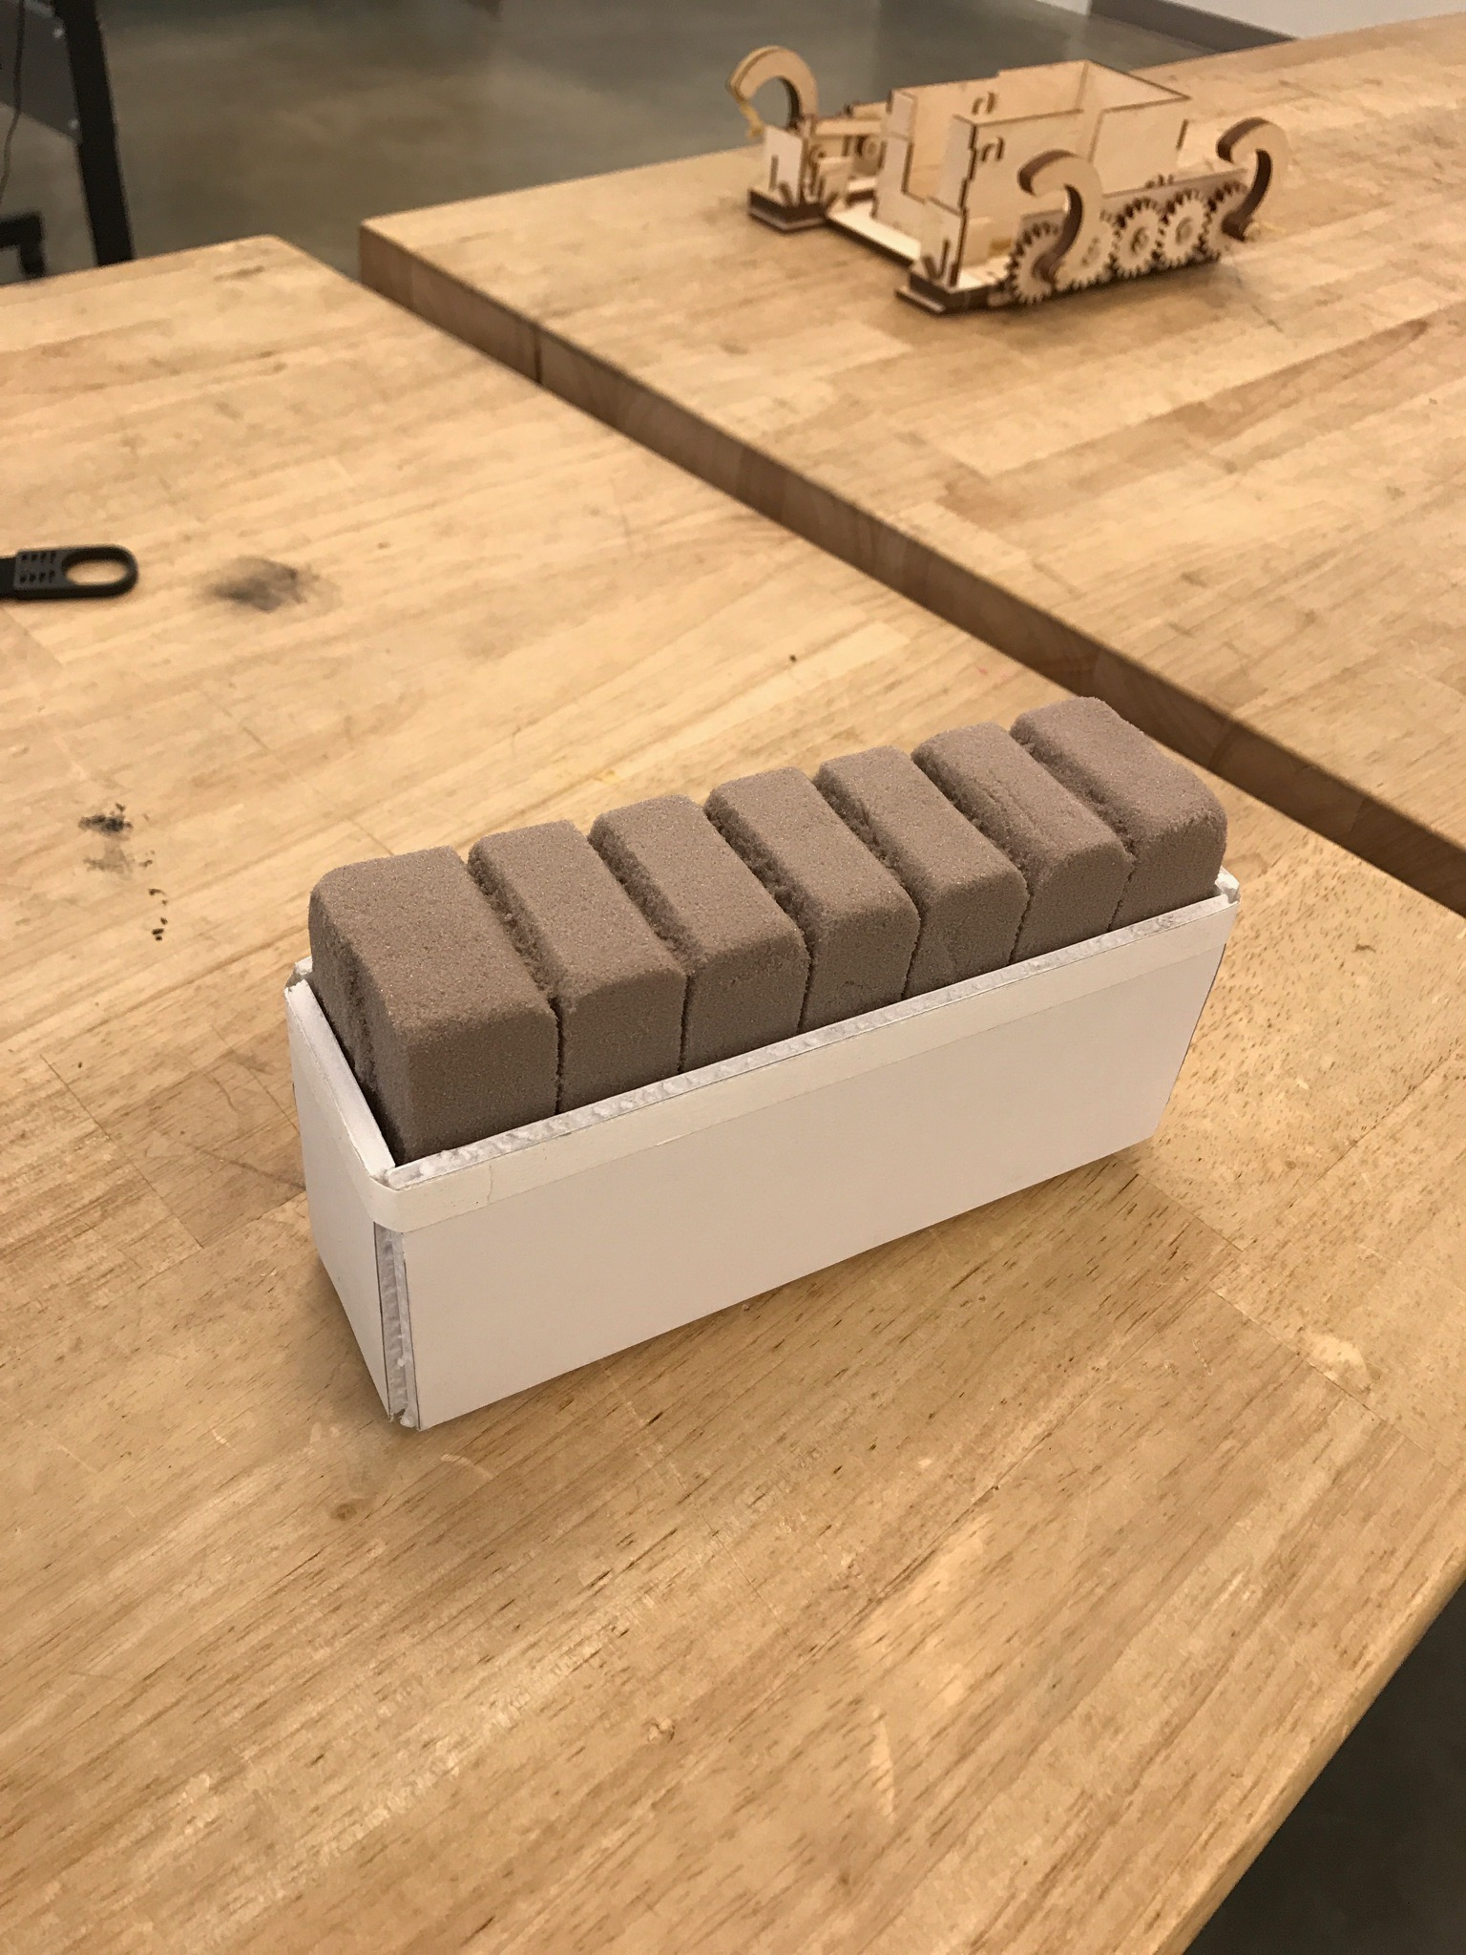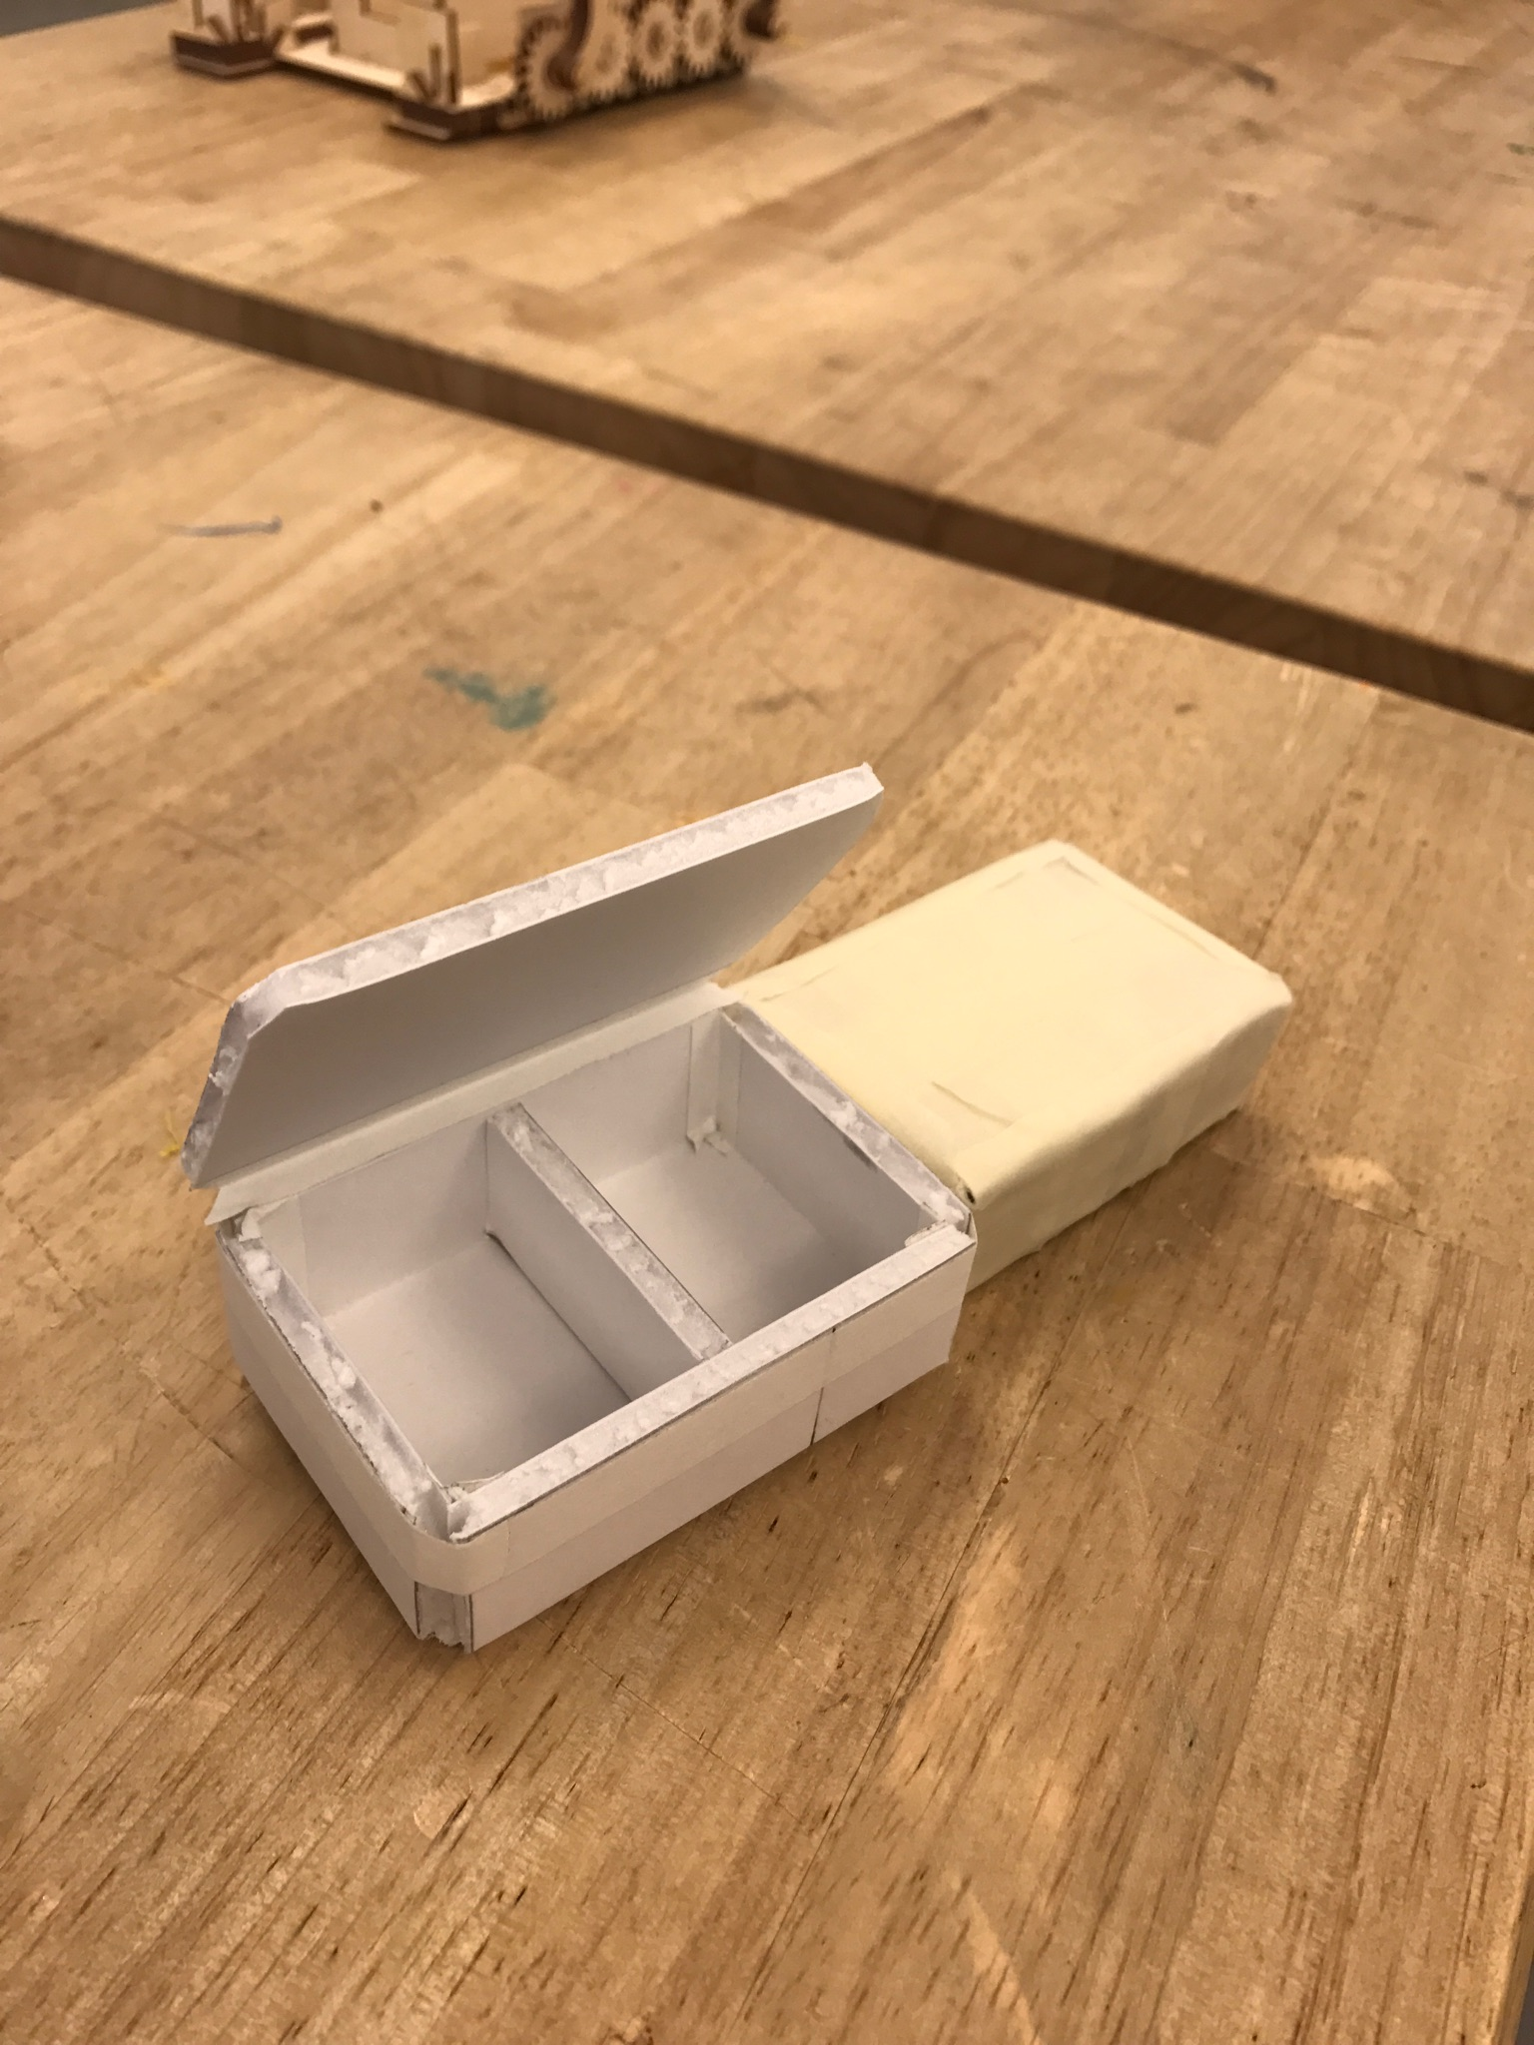

This physical mockup consists of a portable device with a static number of dosage cups attached to the alarm part. We wanted to test out the size of the portable device as well as whether or not a “stacking”/interlocking kind of mechanism could be used with the dosage cups so that the number of cups attachable and thereby usable would be customizable for each individual’s need. The second part of the device is for pill storage. Despite the apparent simplicity, we would need to put a weight sensor or something along the same vein under/in the dosage cups to be able to detect when a dosage cup is empty and needs to be refilled.

**Implementation Prototype:**

**Reflection:**

We’ll have to tinker with the setup of the physical devices to make figure out what design would result in both ergonomic and space-sensitive usage. Additionally, we’ll need to further experiment with ways to send notifications to phone from device. We’ll also need to test out the size and cost constraints that using weight sensors would introduce into the design of the device.